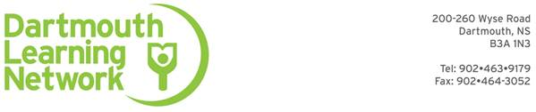
Employment Readiness Class Outline
Classes are held each Wednesday, 9am – 4pm throughout the school year
& include community based workshops and outings scheduled during the week

Understanding the Skills Necessary for Success In the Workplace
Putting together Your Story, Your Accomplishments and Successes
Life, Workplace & Volunteer Experience - Transferrable Skills
What Do Employers Look for in a Good Employee?
Your Unique Learning Style (& how it affects job success)
Discover Your Values
Setting Goals & Mapping Your Unique Career Path
Building an effective Return to Work Action Plan
How to Build a Strong Resume & Cover Letter
Building Bridges to Future Jobs - Positive References
Top Job Search Techniques: Networking, Cold Calls, On-line Career Resources , face-to-face
To Move or Not to Move where the job is
How to Approach Potential Employers with Confidence, Interview Skills
Putting Your Best Foot Forward –Making a Positive Impression
Marketing yourself…Getting the most out of Job Fairs
Your Best Friend is You…Strategies for Improving Self Esteem
Communication Skills (How to talk so people listen & listen so people talk)
Responsibilities, Boundaries – How to Understand the Boss & Negotiate Without Being Fired
Teamwork & Managing Conflict - Being Assertive, Without Being Aggressive
Managing Stress and Health - in the Workplace & at Home
Labour & Workplace Standards
Workplace Safety & Your Rights on the Job
Understanding & Completing Workplace Documents
Skill-on-Line Courses and Certifications
CPR & First Aid Certification, WHMIS Certification
Super Host Certification (Customer Service Course)
Food Handler’s Course Certification
*** Work Placements, Job Performance Evaluations - Opportunities & Choices
Dynamic guest speakers, field trips to interesting work sites,
Film and video presentations, hands on practice, & more

For more information please contact Cathy at: 463-9179, Ext. 225
Or email: class2@dartmouthlearning.net

